

Ref.No.14-22/99-PCI/17339-18162 Date: 21.03.2007
U.P.C.

1. ALL THE INSTITUTIONS CONDUCTING APPROVED DIPLOMA/DEGREE
COURSE IN PHARMACY AND
2. ALL THE EXAMINING AUTHORITIES/UNIVERSITIES HOLDING APPROVED
(DIPLOMA/DEGREE) EXAMINATION IN PHARMACY.

Sub.: New SIF’s for Institutions conducting Diploma course in Pharmacy,
Degree course in Pharmacy and both Diploma & Degree course in
Pharmacy.
Ref.: Our Circular Nos.-
i) 14-22/90-PCI/5556-6047 dt.8.7.99
ii) 14-22/99-PCI-17859-18443 dt.6.3.2002
iii) 14-22/99-PCI-5573-6191 dt.13.7.2002.
Sir/Madam
With reference to the subject cited above, it is informed that Council has revised the SIF’s as under -
1) SIF for institutions conducting D.Pharm course. (SIF-A)
2) SIF for institutions conducting B.Pharm course. (SIF-B)
3) SIF for institutions conducting both D.Pharm & B.Pharm courses simultaneously.
(SIF-C)
The revised SIFs have been launched on the PCI’s website “www.pci.nic.in” and the
same shall be implemented from 2007-2008 academic session. All the institutions
seeking extension of approval are now required to submit the information in the revised
SIFs only.
In this connection, it is again clarified that last date/cut-off date for submission of Standard Inspection Form (SIF) to PCI for consideration of extension of approval of Diploma/Degree course in Pharmacy is 30th September i.e. 9 months in advance of expiry of approval.

…2
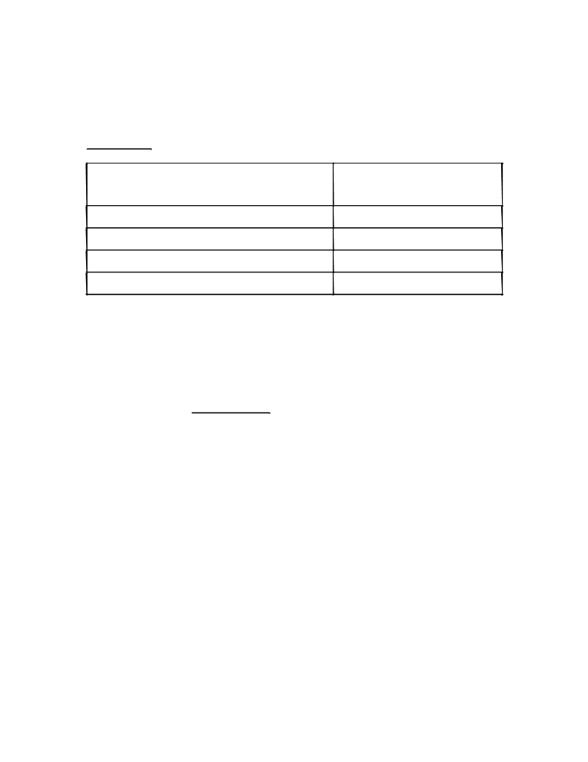

…2...

For Example

If the D.Pharm/B.Pharm course is approved SIF duly filled in, in triplicate
upto shall reach PCI’s office on or
before
2007-2008 academic session 30.9.2007
2008-2009 academic session 30.9.2008
2009-2010 academic session 30.9.2009
2010-2011 academic session and so on 30.9.2010

Please note that :-
i) it is the responsibility of the institution to download the revised applicable SIF
proforma (diploma, degree or both diploma & degree) from the Council’s website and
submit the same duly filled in within the due date as per above schedule. No separate
SIF will be sent by the PCI.
ii) institutions running both D.Pharm & B.Pharm course simultaneously shall submit
SIF-C only. They need not submit separate SIF for diploma (SIF-A) & degree (SIF-
B).
iii) old SIF if submitted will be rejected & no correspondence on this issue will be done
by PCI.
iv) SIF received after the due date will not be entertained by the Council and the
consequences thereof shall rest on the institution.
This is for necessary action and compliance.
Yours faithfully

(ARCHNA MUDGAL)
Registrar-cum-Secretary

