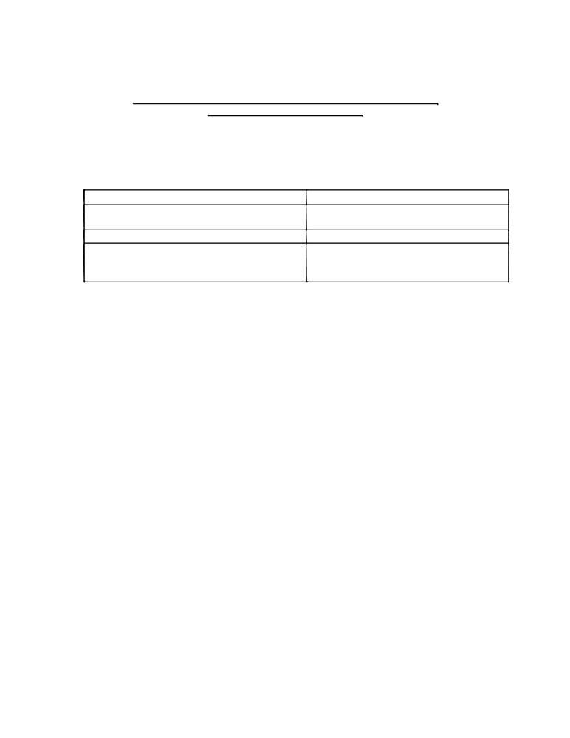

Remittance of Inspection and Affiliation Fee by new institutions
(All Institutions D.Pharm./B.Pharm.)

i) The Council has decided to charge an “Inspection Fee” from January, 2005 in respect of new
diploma and degree institutions approaching the Council for approval as per the following details
No. of Inspections Amount
- For first inspection including second inspection Rs.25,000/- per course (diploma/degree)
if required

- Additional inspection if required Rs.15,000/- per inspection, per course
(diploma/ degree) till approval is granted
by the Council

ii) This Inspection Fee from new institutions will be in addition to Affiliation Fee which is Rs. 15,000/-
per course per annum

iii) Once the new institution is granted approval, no Inspection Fee will be charged for inspection for
further extension of approval and only Affiliation Fee which is Rs. 15,000/- per annum, per course will be charged by the Council.
In view of above, you are requested to forward per return of mail a Demand Draft (not Cheque) in favour of Pharmacy Council of India, payable at New Delhi of -

i) Rs.25,000/- as Inspection fee
ii) Rs.15,000/- as Affiliation fee.

Please note that mere acceptance of inspection fee/affiliation fee does not mean/ensure approval.

